User Manual of

Totoro Ramen System

**Copyright by Group 105**

**1 Introduction**

This is an order and manage system for “Totoro Ramen”. In this software, customer can form an order and do some operation about their own account. Managers can use this software to change some options of ramen and view some statistical data in the restaurant.

**2 Operation Interface**

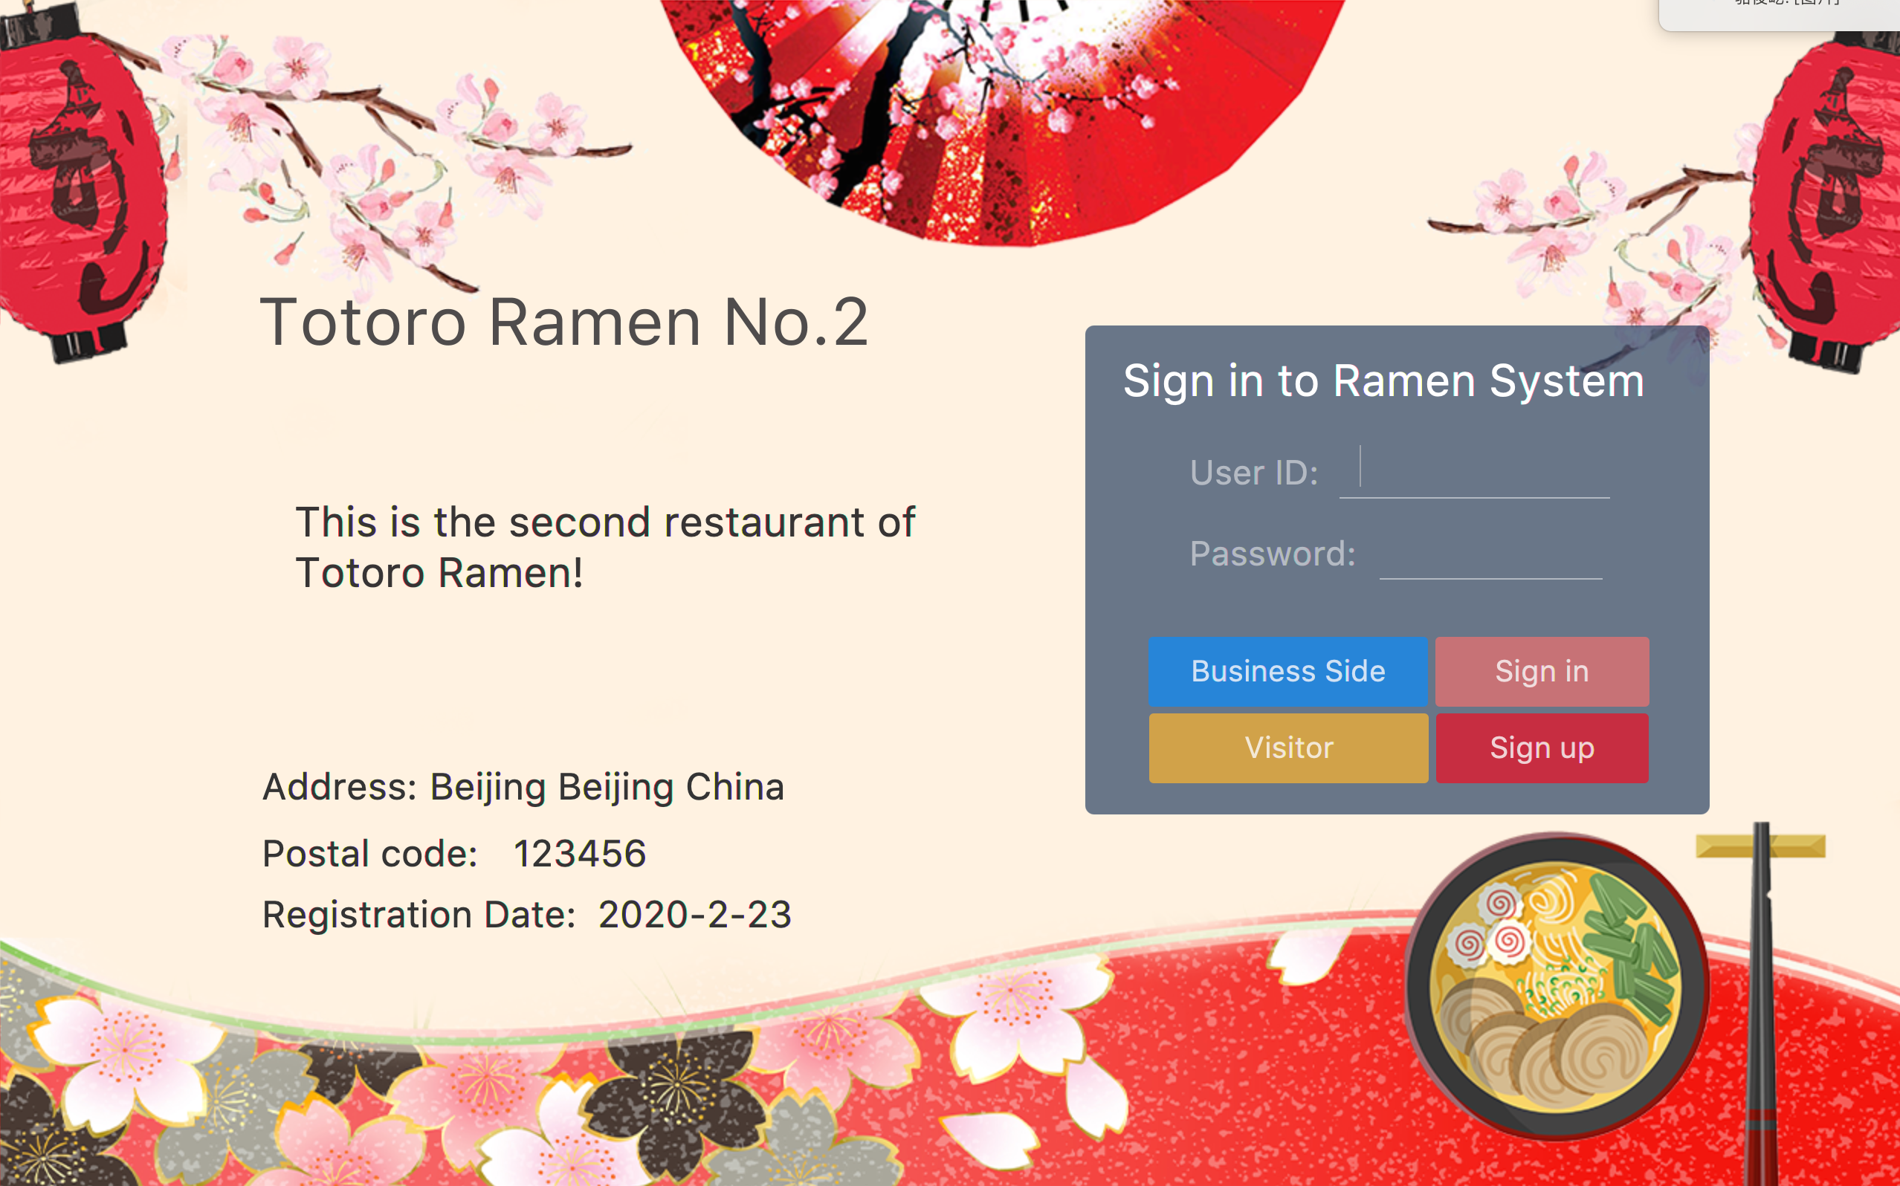

Figure 2-1

First of all, as figure 2-1 shows, in the login interface, users can select “Sign in”, “Sign up” or use this system as a visitor. **Managers can select the “Business side” button to enter the business interface**. User can also see the information about the restaurant on the left side.

**2.1 Customer side**

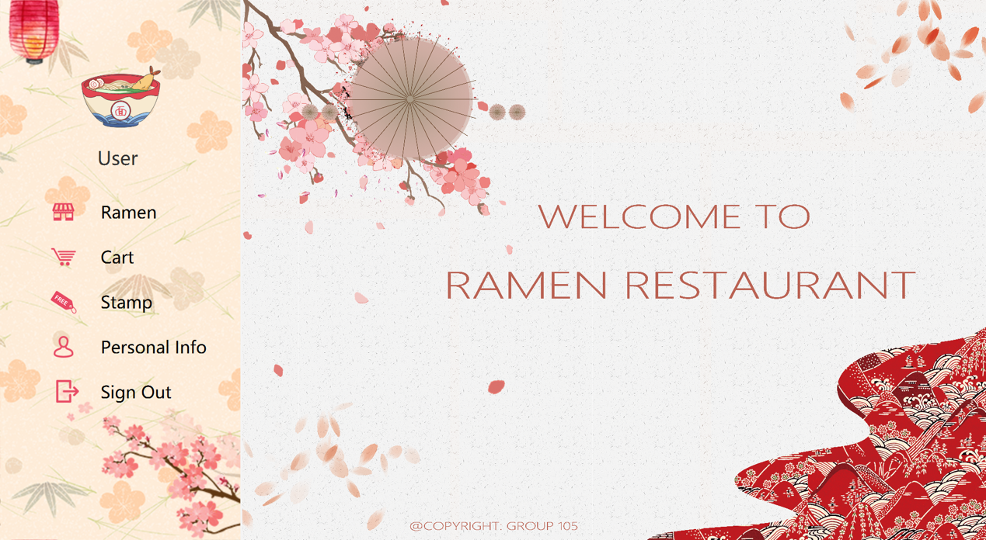

Figure 2.1-1

If the customer is signed in with the personal account, it will show the welcome interface as figure 2.1-1. In the left panel, user can select “Personal info” to see the information about this account.

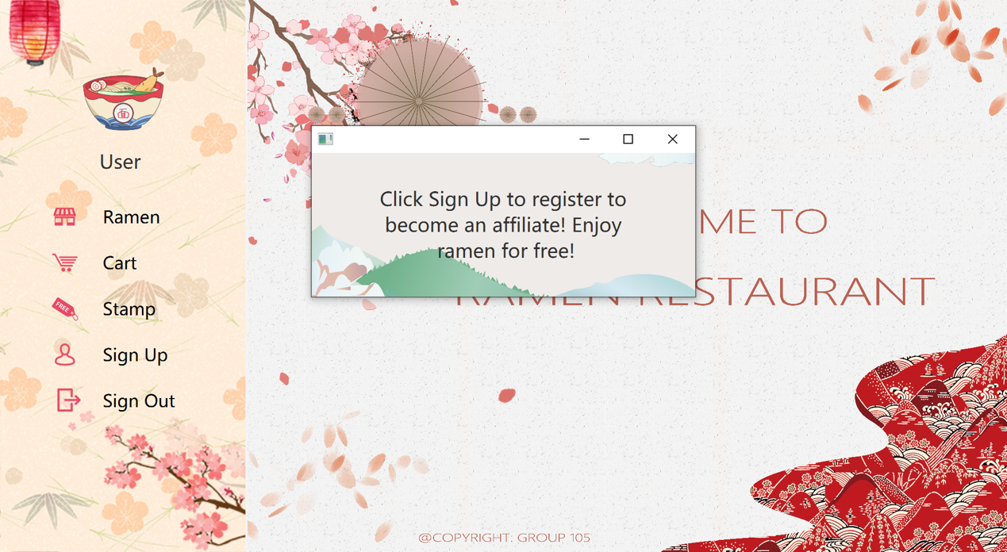

Figure 2.1-2

Or the customer signs in as a visitor, the system will notice the user to sign up and there will be a “Sign up” button instead of “Personal info” shown in figure 2.1-2.

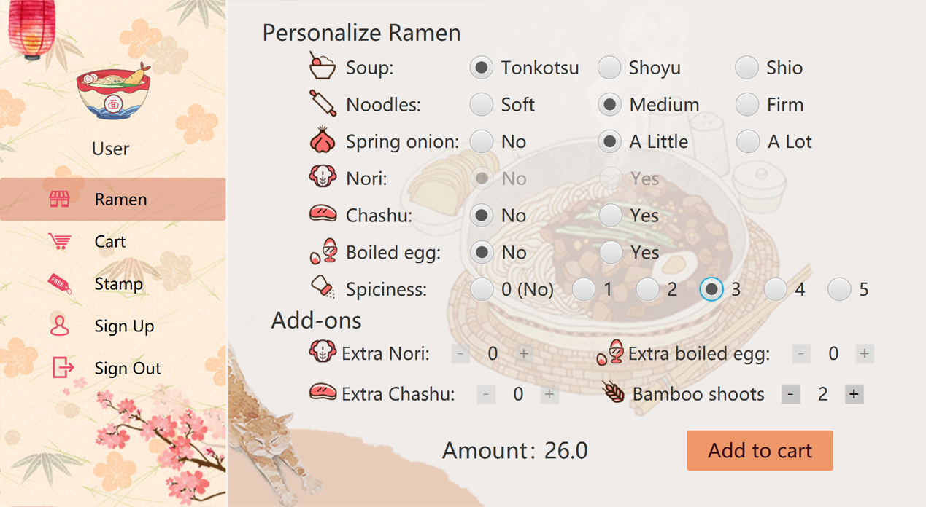

Figure 2.1-3

In figure 2.1-3, we can see, there is 5 buttons in the left panel. “Ramen” is the place where the customer can select the options for a ramen. These options can be managed by the manager side to choose which options are available or not. Some options are constraint by the each other, such as if “Noir” is not available and the option of “Extra Nori” cannot be selected in the area of “Add-Ons”. Customer can see the amount of the current ramen at the button of this interface in real time. After doing this, click the “Add to cart” button and this ramen can be added to the shopping cart.

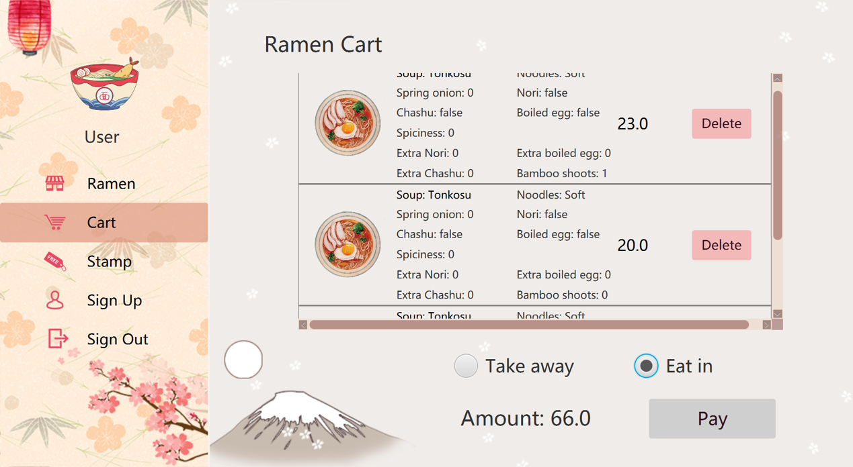

Figure 2.1-4

Figure 2.1-4 shows the shopping cart interface. In this place, all the ramens in order are shown and customer can delete some of them and check whether there are some mistakes to make sure that these are what they want. Customer cam also select eat in or take away. The function of shopping cart allows customer pay more than one bowl of ramen for one time, don’t need to repeat again and again. After this click “Pay” button to enter the payment window.

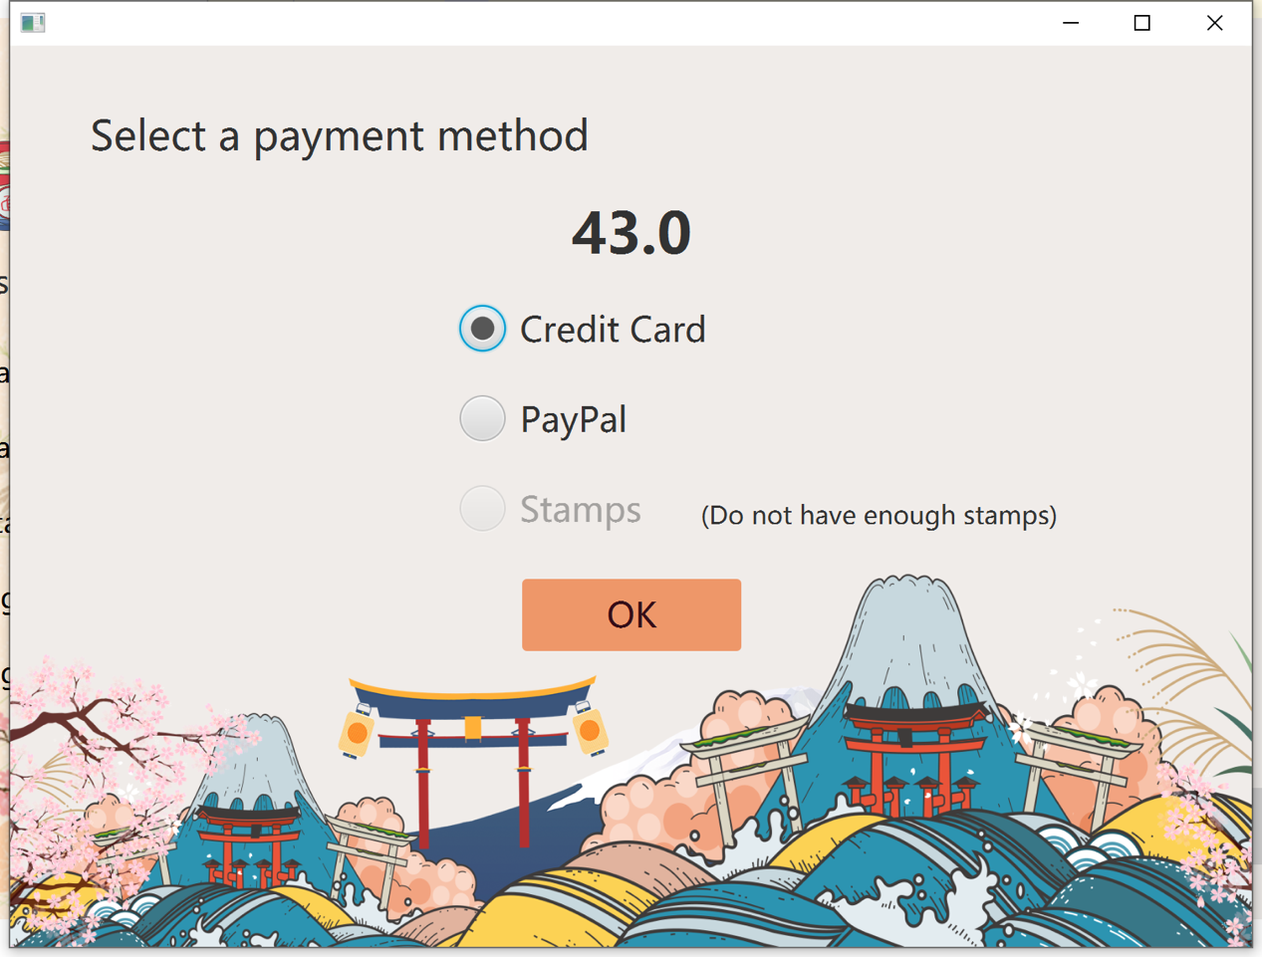

Figure 2.1-5

In the payment window, customer can select several payment methods. Only when the stamps are enough for a free order, custom can select pay this order with this method or they can only select another two methods. After payment, this system will print a tick with information about the order.

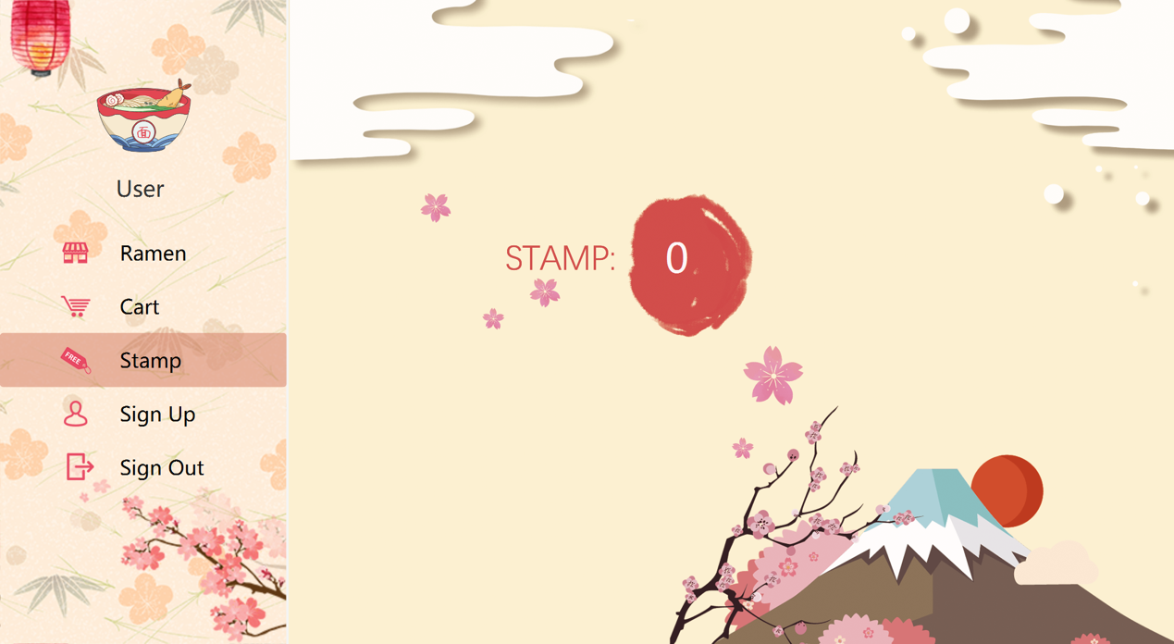

Figure 2.1-6

Customer can see the stamps in the stamp interface as shown in figure 2.1-6.

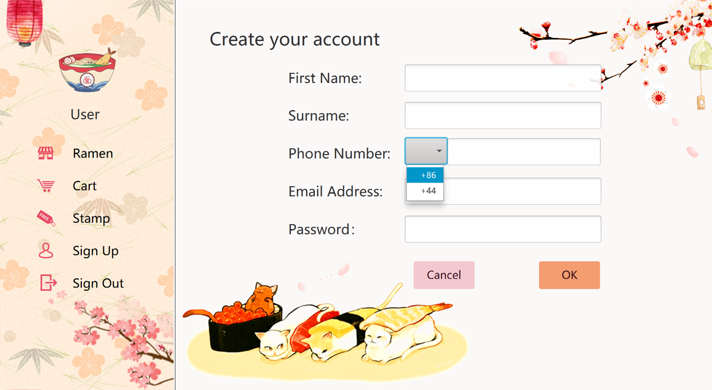

Figure 2.1-7

If the customer selects to sign up as a visitor, this interface shown in figure 2.1-7 allows the customer to fill in personal information to become a membership.

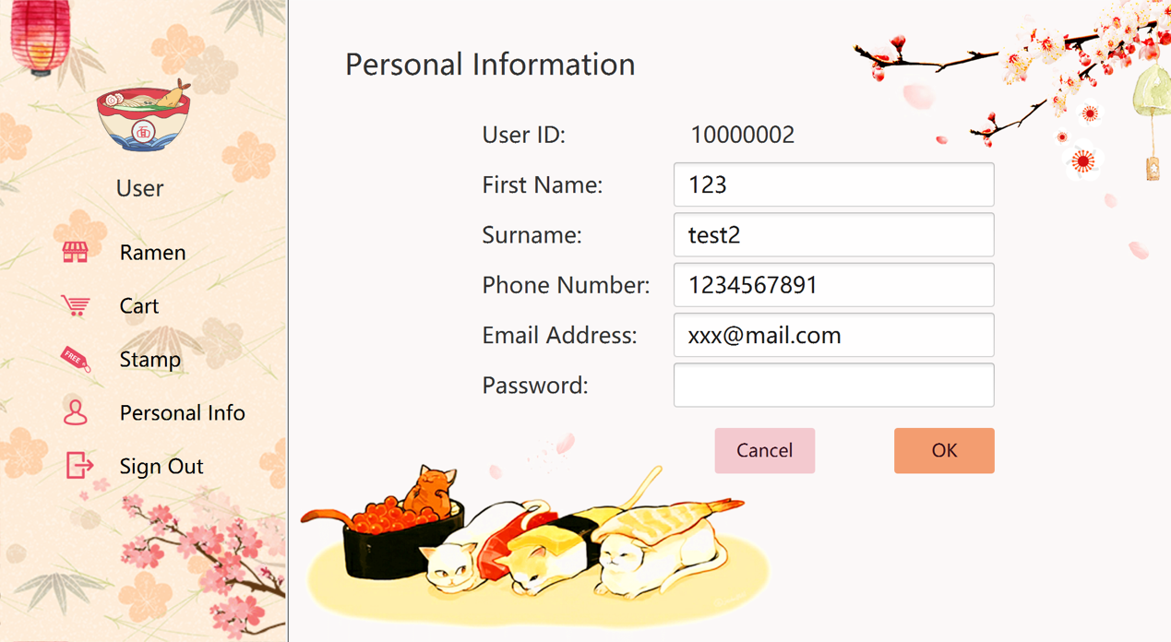

Figure 2.1-8

Or the customer signs up with account, in the personal info interface, customer can take a look of the information and modify this information as figure 2.1-8.

**2.2 Business side**

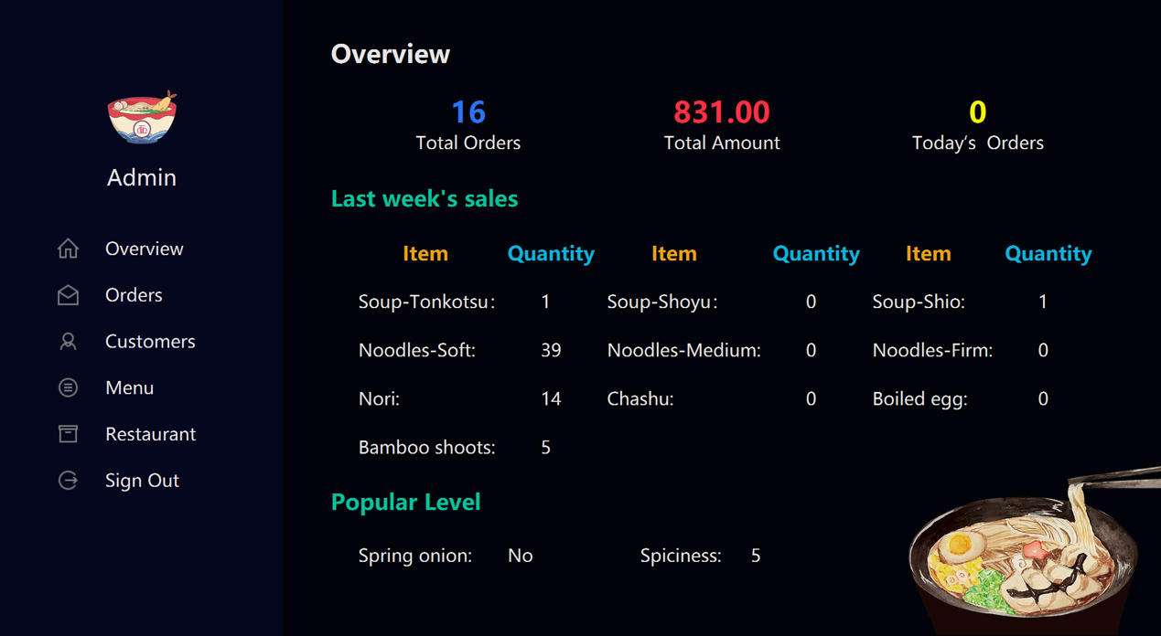

Figure 2.2-1

In the business side, manager can get an overview of some statistical data of the restaurant as figure 2.2-1.

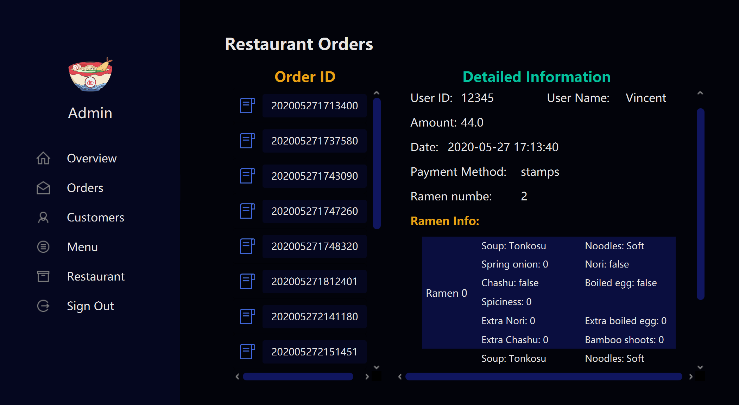

Figure 2.2-2

In the order interface, managers can see all the orders of the restaurant and order id is made up of the generation time of the order. All the information about the selected order is shown on the right side as figure 2.2-2.

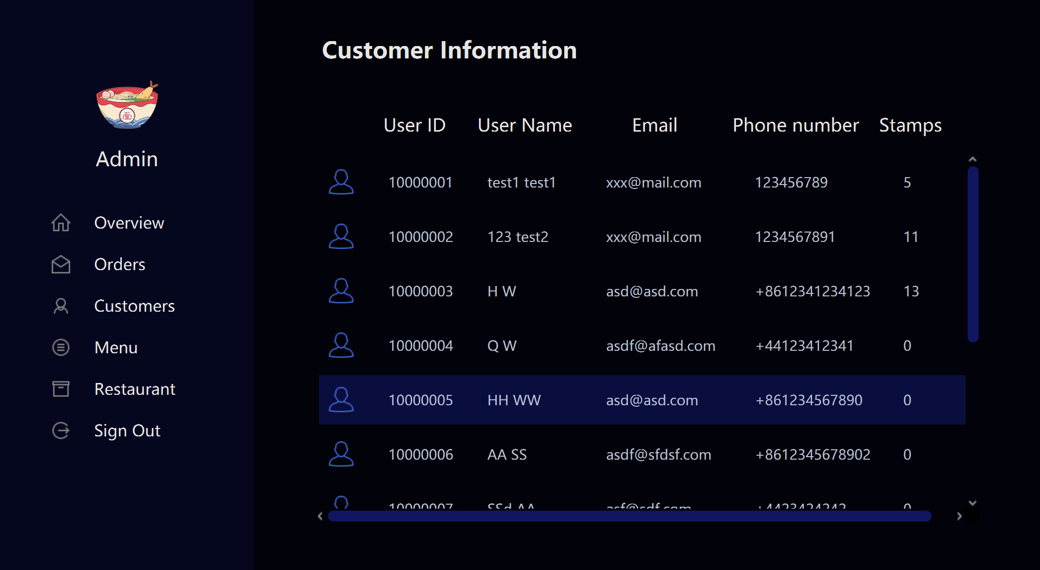

Figure 2.2-3

In the customer interface managers can see some basic information of the registered users as figure 2.2-3.

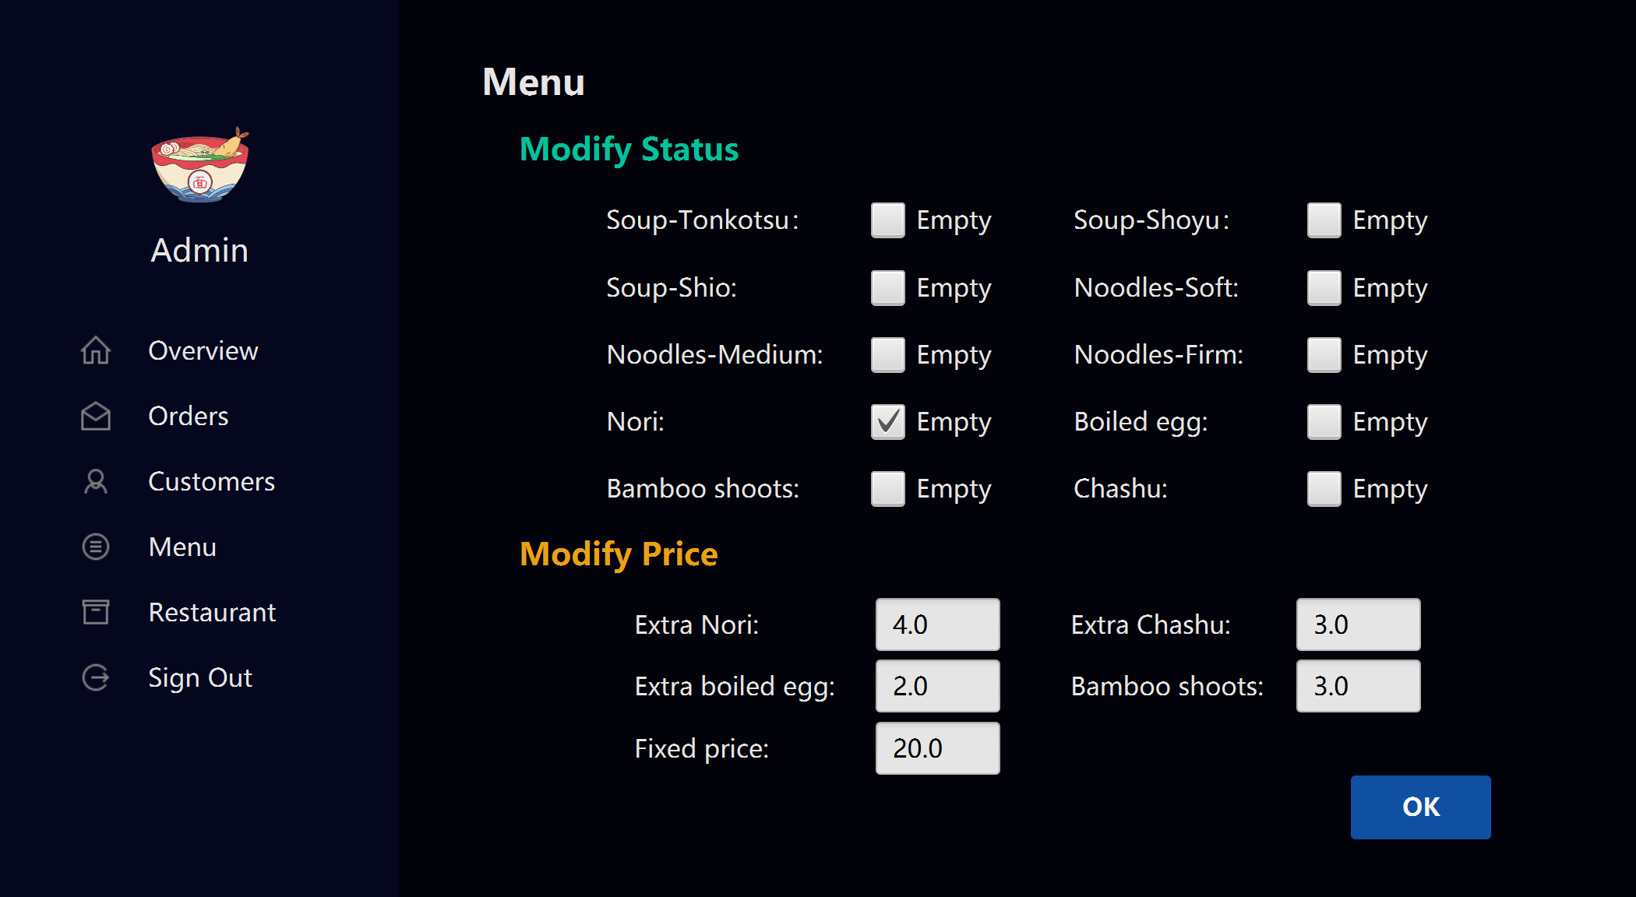

Figure 2.2-4

The managers can select whether the options of ramen is available and also modify the price of the fixed price of ramen and add-ons as figure 2.2-4.

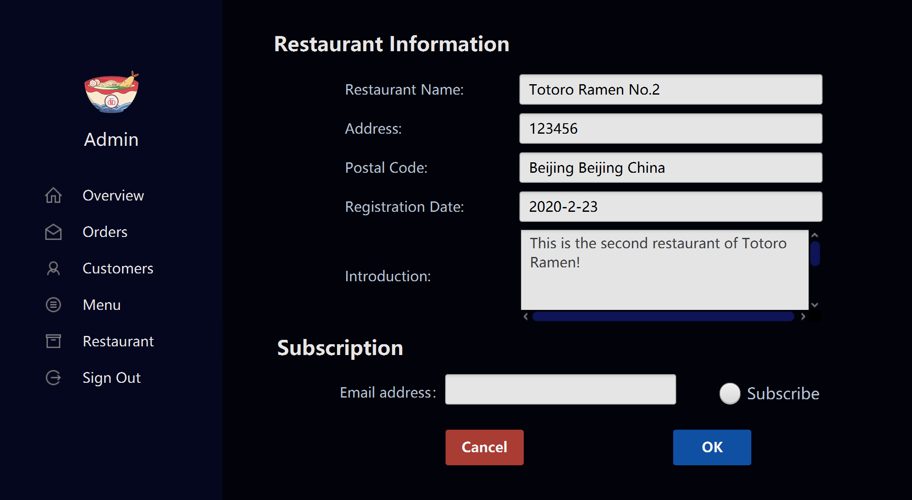

Figure 2.2-5

The restaurant is shown in the restaurant interface and managers can change them as they like. They can also subscribe the report the some data about the restaurant by entering their email address and click ok button.